WOODLANDS FAMILY PRACTICE
Statement of Purpose
Health and Social Care Act 2008

Woodlands Family Practice Woodlands Road Gillingham
Kent ME7 2BU

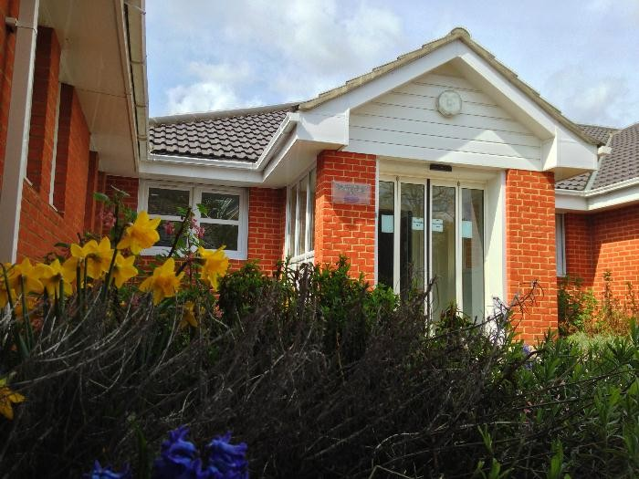
01634 854431
woodlandsfamilypractice@nhs.net Registered Manager: Dr Naveen Rishi
Practice Manager: Jo Nightingale jo.nightingale@nhs.net
Service Provider ID: 1-199738341 Registered Manager ID: GMC-4363400

Our Aim and Objectives:

- To provide the best possible quality service for our patients within a confidential and safe environment by working together.

- Vulnerable members of society are safeguarded from abuse, or the risk of abuse, and their human rights are respected and upheld.

- To show our patients courtesy and respect at all times irrespective of ethnic origin, religious belief, personal attributes, or the nature of the health problem.

- To involve our patients in decisions regarding their treatment.

- To promote good health and well being to our patients through education and
information.

- To involve allied healthcare professionals in the care of our patients where it is in their
best interests.

- To encourage our patients to get involved in the practice through an annual survey and encouragement to comment on the care they receive.

- To ensure that all members of the team have the right skills and training to carry out
their duties competently.

Partners of the practice:

Dr Chottakoriande Ashok Dr Prem Bakshi
Dr Nand Rishi Dr Naveen Rishi
Dr Farzin Yazamaidi
Dr Madu Ganeshbhai Patel

Woodlands Family Practice at Gillingham was purpose built in April 1997. Since then we have become a training practice and have needed to extend. The practice now has 23 consulting rooms, a treatment room, a large conference room and a pharmacy on site. We have full disabled access to the practice, plus a large car park including disabled and mother and baby parking spaces.

Due to us being a training practice we regularly have trainee GP’s on work placements lasting between four and twelve months. This is in addition to our regular team of 6 GP Partners, 7 salaried GP’s, GP Registrar and 8 Nurses 1HCA. The surgery is run by Jo Nightingale, the Practice Manager, and assisted by a Deputy Practice Manager. In addition to this we have 4 secretaries, 5 admin staff, 15 receptionists and 2 prescribing clerks.

Our current list size is 19,650 patients November 2019

Woodlands Family Practice offer these regulated activities :
Diagnostic and Screening Procedures Family Planning
Maternity and Midwifery Services Surgical Procedures
Treatment of Disease, Disorder or Injury

We are able to treat a large range of the population, including:

- children between 0-18 years,
- older people,
- younger adults,
- those with learning disabilities or autistic spectrum disorder,
- those with mental health issues, including people detained under the Mental Health Act,
- those with physical disability,
- those with sensory impairment,
- those with dementia,
- those who misuse drugs and alcohol,
- those with an eating disorder.

Version: 3 Date of Next Review: November 2020

