WOODLANDS FAMILY PRACTICE

Statement of Purpose

Health and Social Care Act 2008

# Woodlands Family Practice Woodlands Road Gillingham

Kent ME7 2BU

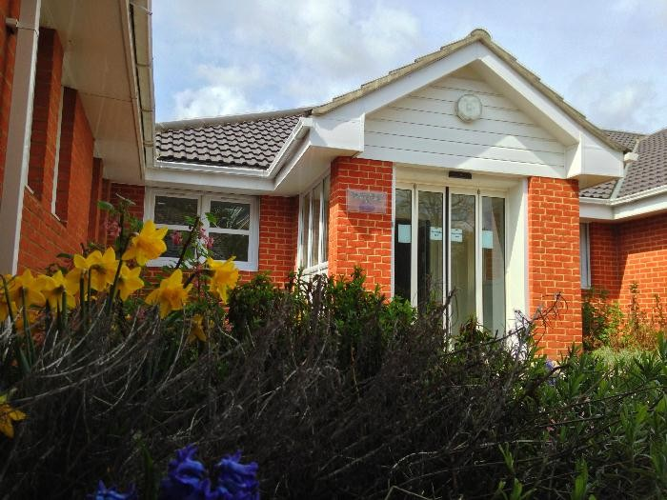

01634 854431

[woodlandsfamilypractice@nhs.net](mailto:woodlandsfamilypractice@nhs.net) Registered Manager: Dr Naveen Rishi

Practice Manager: Jo Nightingale [jo.nightingale@nhs.net](mailto:jo.nightingale@nhs.net)

Branch Surgery Address: Rainham Healthy Living Centre Green Suite

103-107 High Street Rainham

Kent ME8 8AA

Service Provider ID: 1-199738341 Registered Manager ID: GMC-4363400

# Our Aim and Objectives:

1. To provide the best possible quality service for our patients within a confidential and safe environment by working together.
2. Vulnerable members of society are safeguarded from abuse, or the risk of abuse, and their human rights are respected and upheld.
3. To show our patients courtesy and respect at all times irrespective of ethnic origin, religious belief, personal attributes, or the nature of the health problem.
4. To involve our patients in decisions regarding their treatment.
5. To promote good health and well being to our patients through education and

information.

1. To involve allied healthcare professionals in the care of our patients where it is in their

best interests.

1. To encourage our patients to get involved in the practice through an annual survey and encouragement to comment on the care they receive.
2. To ensure that all members of the team have the right skills and training to carry out

their duties competently.

Partners of the practice:

Dr Chottakoriande Ashok Dr Prem Bakshi

Dr Nand Rishi Dr Naveen Rishi

Dr Farzin Yazamaidi

Dr Madu Ganeshbhai Patel

Woodlands Family Practice at Gillingham was purpose built in April 1997. Since then we have become a training practice and have needed to extend. The practice now has 23 consulting rooms, a treatment room, a large conference room and a pharmacy on site. We have full disabled access to the practice, plus a large car park including disabled and mother and baby parking spaces.

Due to us being a training practice we regularly have trainee GP’s on work placements lasting between four and twelve months. This is in addition to our regular team of 6 GP Partners, 7 salaried GP’s, GP Registrar and 8 Nurses 1HCA. The surgery is run by Jo Nightingale, the Practice Manager, and assisted by a Deputy Practice Manager. In addition to this we have 4 secretaries, 5 admin staff, 15 receptionists and 2 prescribing clerks.

Our current list size is 19,650 patients November 2019

Woodlands Family Practice offer these regulated activities :

Diagnostic and Screening Procedures Family Planning

Maternity and Midwifery Services Surgical Procedures

Treatment of Disease, Disorder or Injury

We are able to treat a large range of the population, including:

- children between 0-18 years,

- older people,

- younger adults,

- those with learning disabilities or autistic spectrum disorder,

- those with mental health issues, including people detained under the Mental Health Act,

- those with physical disability,

- those with sensory impairment,

- those with dementia,

- those who misuse drugs and alcohol,

- those with an eating disorder.

Version: 3 Date of Next Review: November 2020